**Exp. No : 10**

**VISUALIZE DATA USING ANY PLOTTING FRAMEWORK**

1. **Scatter Plot**

# Install ggplot2 (if not already installed)

install.packages("ggplot2")

# Load the ggplot2 package

library(ggplot2)

# Scatter plot of Sepal.Length vs Sepal.Width, colored by Species

ggplot(data = iris, aes(x = Sepal.Length, y = Sepal.Width, color = Species)) +

geom_point(size = 3) + # Adds points

labs(title = "Scatter Plot of Sepal Dimensions",

x = "Sepal Length (cm)",

y = "Sepal Width (cm)") + # Adds axis labels and title

theme_minimal() # Applies a minimal theme

**Output :**



1. **Bar Chart**

# Install ggplot2 (if not already installed)

install.packages("ggplot2")

# Load the ggplot2 package

library(ggplot2)

# Bar plot of Species counts

ggplot(data = iris, aes(x = Species)) +

geom_bar(fill = "steelblue") + # Adds bars filled with steel blue color

labs(title = "Count of Different Species in Iris Dataset",

x = "Species",

y = "Count") +

theme_minimal()

**Output :**

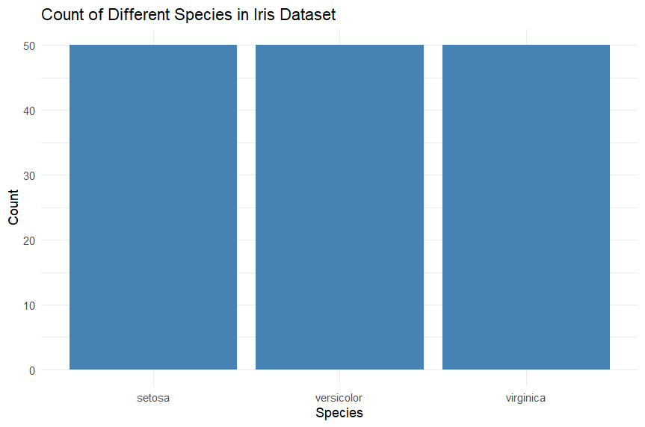

1. **Histogram**

# Install ggplot2 (if not already installed)

install.packages("ggplot2")

# Load the ggplot2 package

library(ggplot2)

# Histogram of Sepal Length

ggplot(data = iris, aes(x = Sepal.Length)) +

geom_histogram(binwidth = 0.3, fill = "orange", color = "black") + # Adds histogram bars

labs(title = "Histogram of Sepal Length",

x = "Sepal Length (cm)",

y = "Frequency") +

theme_minimal()

**Output :**

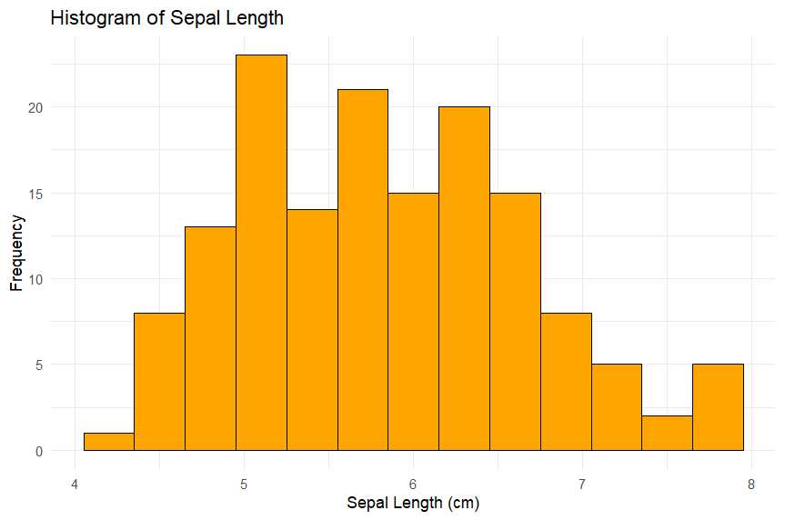

1. **Box Plot**

# Install ggplot2 (if not already installed)

install.packages("ggplot2")

# Load the ggplot2 package

library(ggplot2)

# Box plot of Sepal Length for each Species

ggplot(data = iris, aes(x = Species, y = Sepal.Length, fill = Species)) +

geom_boxplot() + # Adds box plot

labs(title = "Box Plot of Sepal Length by Species",

x = "Species",

y = "Sepal Length (cm)") +

theme_minimal()

**Output :**

